**Exercise f-anoGAN**

Jirayu Petchhan, D10907801

**Training wgan-gp model (Backbone GANs)**

Training with number of epochs = 200

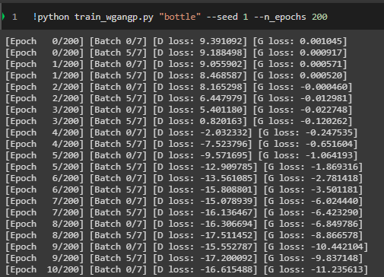

…

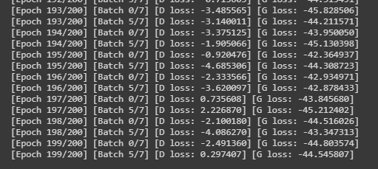

**Then, Training encoder izif model (f-anoGANs)**

Training with **MSE loss** criterion and number of epochs = 200

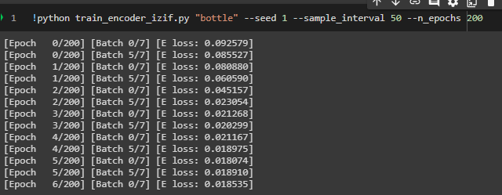

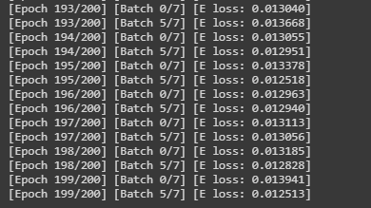

Install package of SSIM.

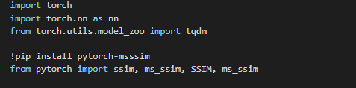

Set up incoming SSIM loss.

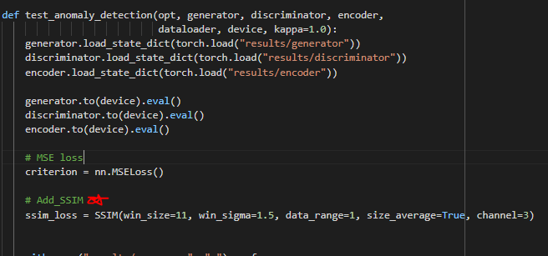

For training iteration

Default **MSE loss**

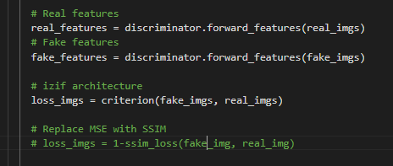

changing criterion to **SSIM_loss** to find image distance.

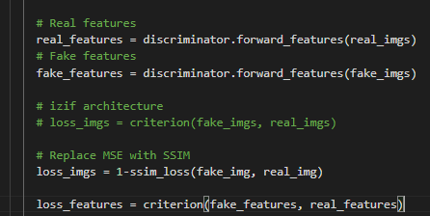\

The result from training iteration with **SSIM loss** criterion and number of epochs = 200

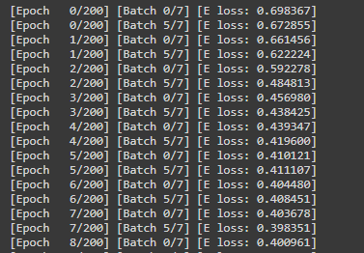

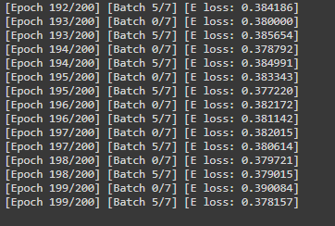

**The results**

Testing with **MSEloss**

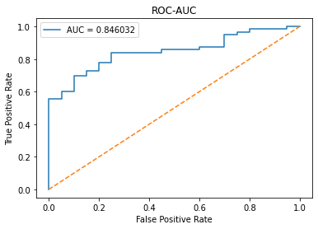

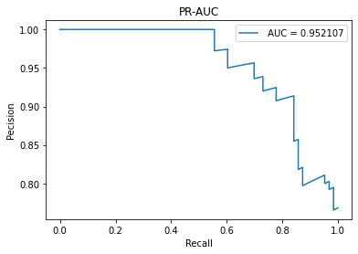

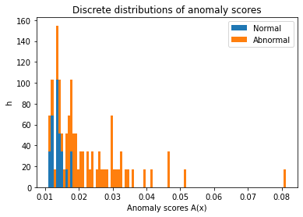

The compared image

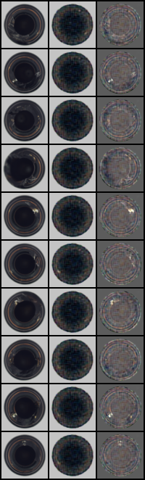

Testing with **MS_SSIM loss**

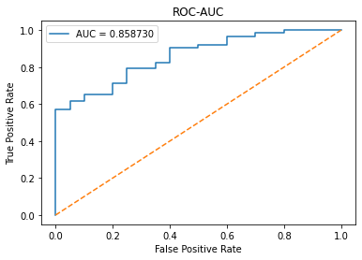

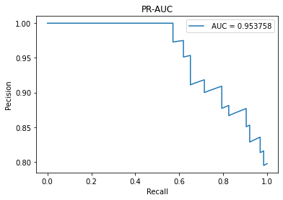

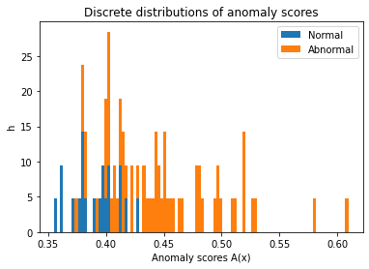

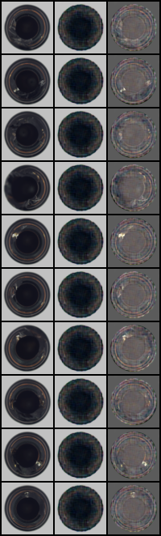

**Conclusion**

As the result from training and testing of MSE loss and SSIM loss, we got ROC-AUC and PR-AUC of SSIM loss more than MSE loss (The little value is much better that might be the epochs is a few (200 epochs)).